

***VIEH PRIVATE LIMMITED***

***Cyotek Sphinx***

**BY Meet Pandya, Rahul Sani**

**04/09/2022**

**Index**

|  |  |  |
| --- | --- | --- |
| **Sr No** | **Name** | **Page** |
| 1. | Acknowledgment | 3 |
| 2. | Introduction | 4 |
| 3. | Pre Requirements | 4 |
| 4. | Time Taken | 4 |
| 5. | About Tool | 5 |
| 6. | How It Work | 6 |

**Acknowledgment**

First and foremost, I would like to thank our Internship Host Manish Kumar sir who given us opportunity. He provided us with invaluable advice and helped us. Besides, we would like to thank all who helped us by giving us advice and providing the equipment which we needed. Also I would like to thank my family and friends for their support. Without that support we couldn’t have succeeded in completing this project. This Project is fully made by us all the content and the program is written by us.

-Meet Pandya

-Rahul Sani

**Introduction**

The Cyotek Sphinx started as mapping the internet and how each website was connected to each other. It was also used by search engines in order to discover and index new online pages. Web crawlers were also used to test website’s vulnerability by testing a website and analysing if any issue was spotted.

Cyotek Sphinx used to collect information which can then be used and processed to classify documents and provide insights about the data collected.

**Pre Requirement**

To use Cyotek Sphinx You have a pycharm install in your operating system (Windows, Linux).



**Time Taken**

To Make Cyotek Sphinx we took 30 to 40 days we spent 3 to 4 hr per week.

**Cyotek Sphinx**

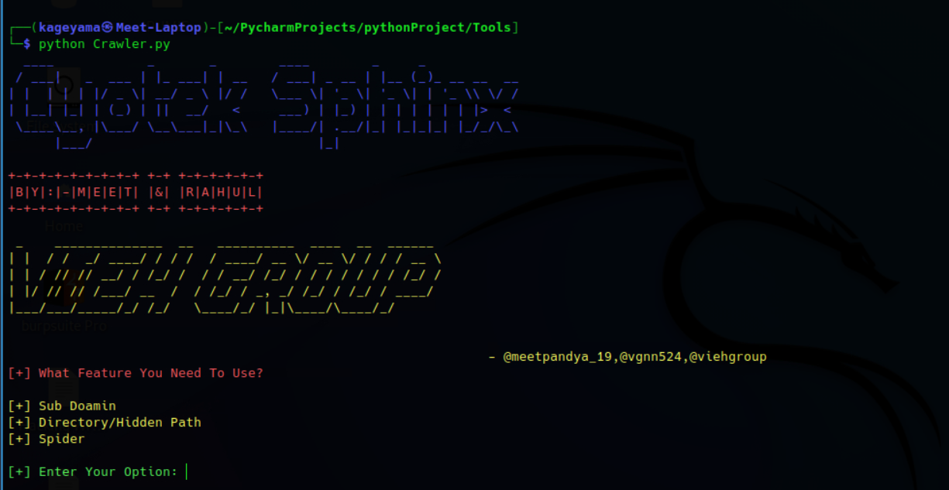

Cyotek Sphinx is a web crawler to get the data of your target website.

You Can find a Subdomain, files, hidden path, and links of the website

Cyotek Sphinx has 3 main features:-

[1]. Sub Domain

[2]. Files/ Hidden Path

[3]. Spider

**How It Work**

**To Use Cyotek Sphinx write command in your Linux terminal – python crawler.py**

Cyotek Sphinx Is used by 3 main features:-

*[1]. Sub Domain Finder*

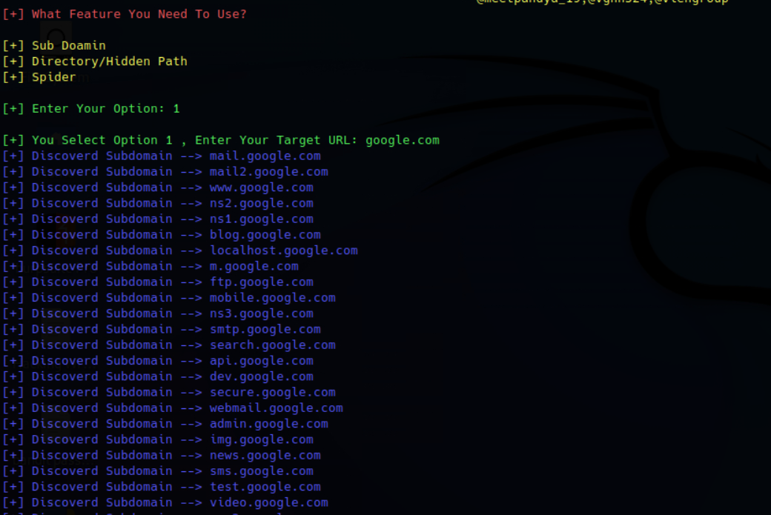

In 1st option you just have to provide the target url (google.com) and the tool provide you all the possible subdomain.

*[2]. Files/Hidden Path*

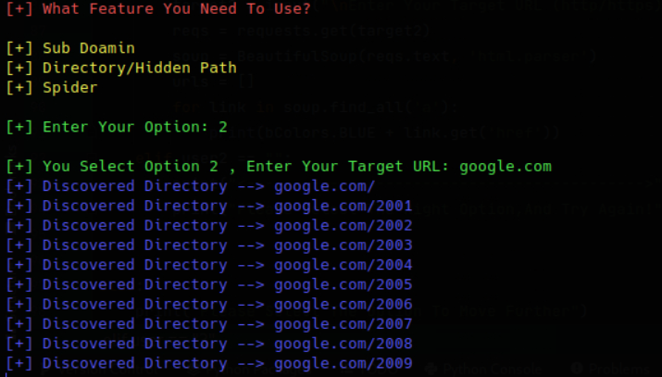

In 2nd feature you have to provide the target url and the tool is provide you every possible file and path of your target url.

*[3]. Spider*

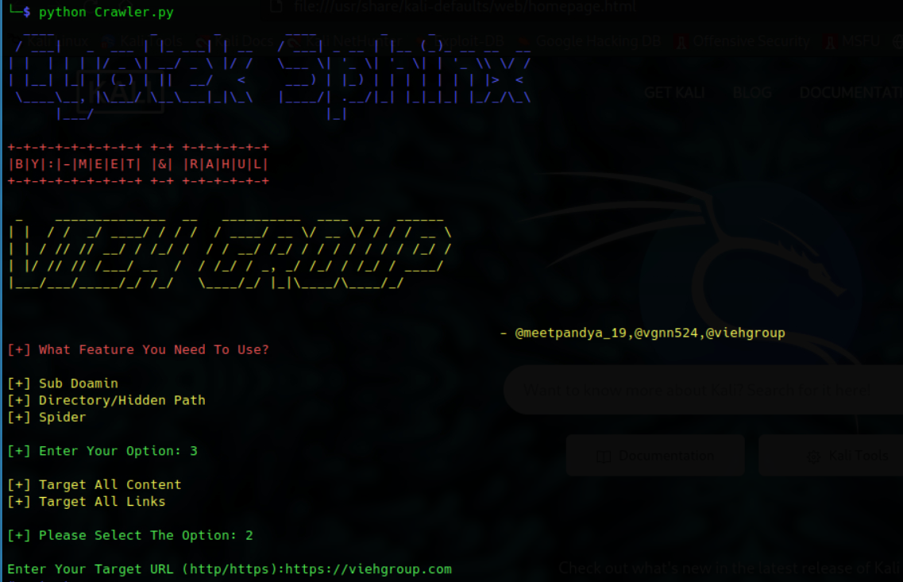

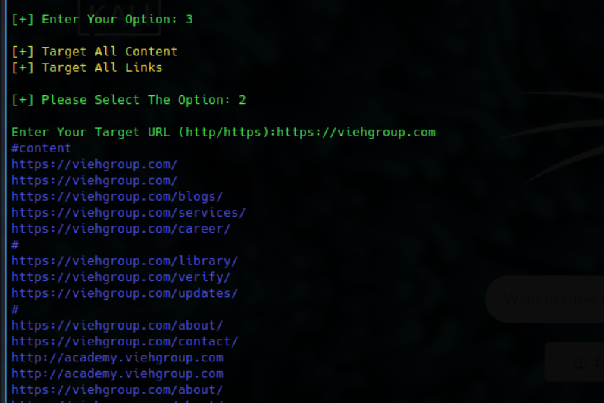

In 3rd feature you have to select the 2 option [1]. Target source code [2]. Target all the links.

1st option provide you the source code of your target.

2nd option provide you the all the links that is used by your target.

So, this is all about Cyotek Sphinx a web crawler.

**Thank You**